A1132-Afr-Egy-Apis Bull-Sun Disk-Uraeus-25th-30th Dynasty-1069-500 BCE-Bronze

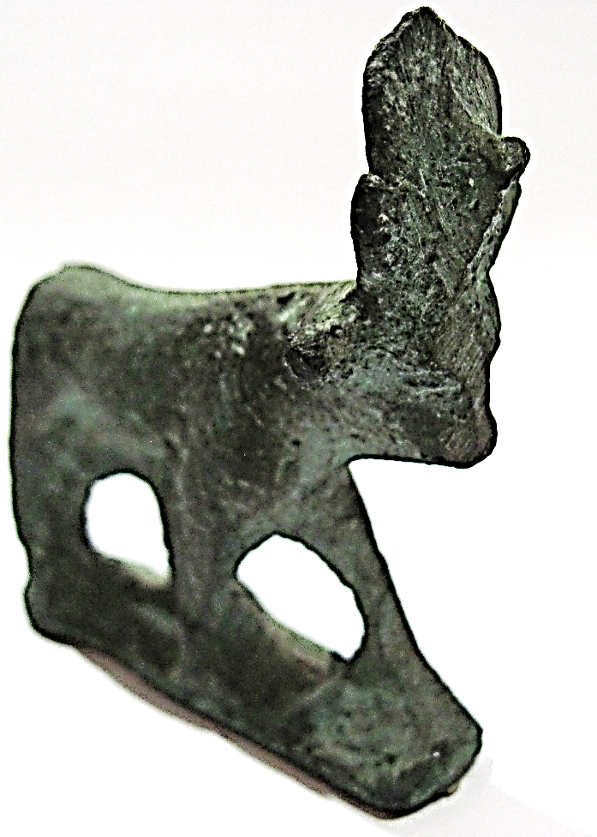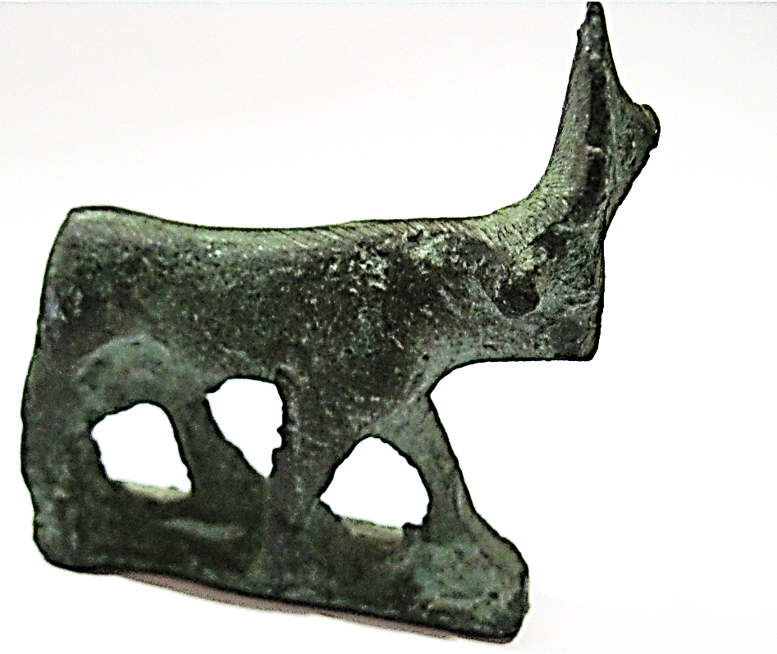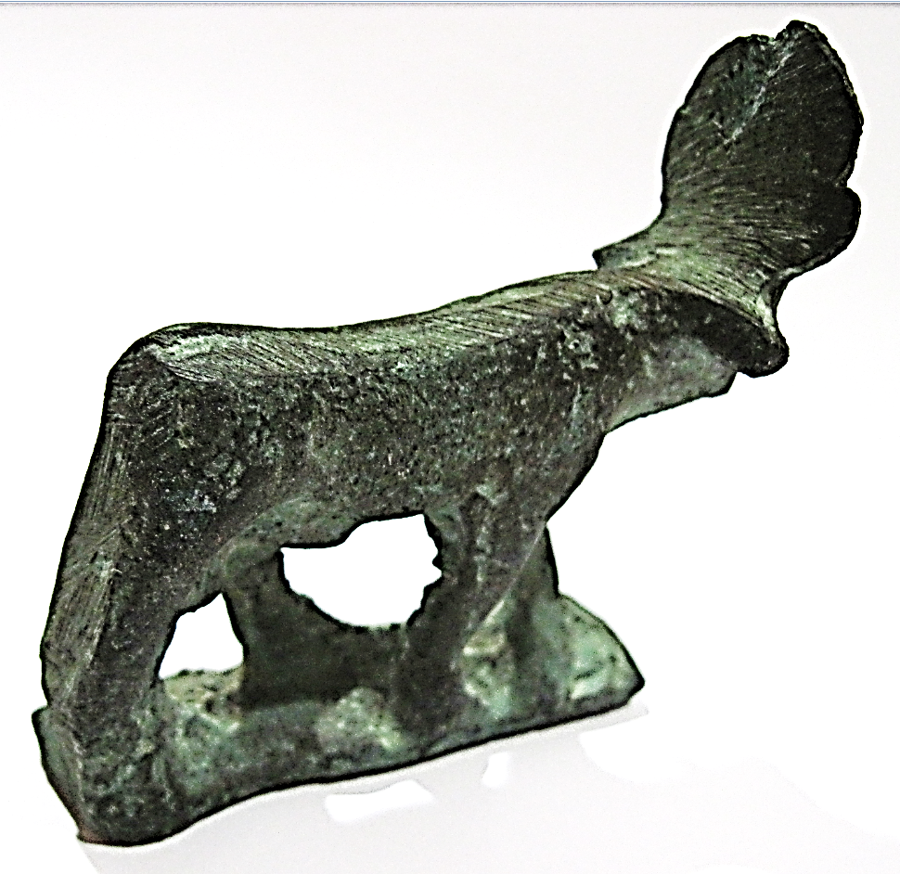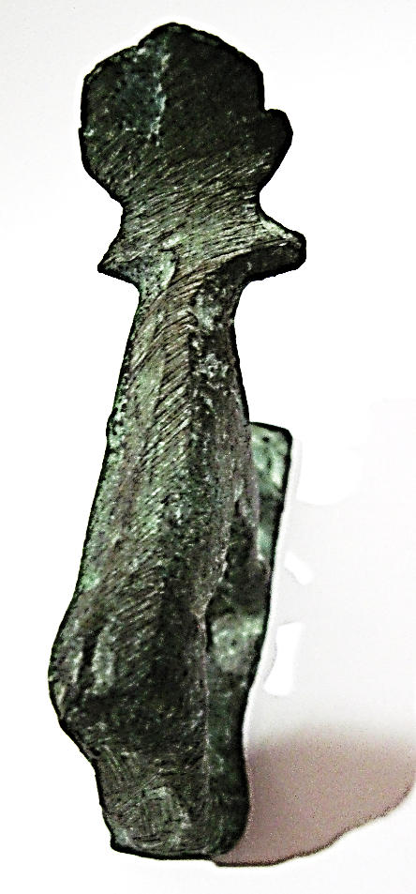

Figs. 1-4. Apis Bull-Sun Disk-Uraeus-25th-30th Dynasty-1069-500 BCE

**Case no.: 3**

**Accession Number: A1132**

**Formal Label:** Apis Bull-Sun Disk-Uraeus-25th-30th Dynasty-1069-500 BCE

**Display Description:**

Apis was a bovine fertility deity associated with the sun god Re/Ra beginning in the Pre-Dynastic Period. The petroglyph image of the bull’s horns enclosing the Sun disk at Maia Dib in Tripolitania confirms that the origins of Egyptian mythology are pre-sedentary when cattle husbandry was the chief economic activity of the Egyptians. Furthermore, it also points to the western desert as the locus of these origins, when this area was far more fertile than at present. Specifically, these images have been identified also at Gif Uweinat in southern Libya where the worship of bovines as a fertility deity is antecedent to the development of the Hathor Cult.

Votive Apis bulls were deposited in the Serapeum of Saqqara, northwest of the Pyramid of Djoser’s Pyramid in Lower Egypt. [Apis bulls](https://en.wikipedia.org/wiki/Apis_(Egyptian_mythology)) were thought to be incarnations of the deity Ptah and that they became immortal after death like [Osiris](https://en.wikipedia.org/wiki/Osiris)-Apis, a name which was shortened from “ oSIRisAPIS” to “Serapis” in the Hellenic period.

**LC Classification:** [N7760](http://lms01.harvard.edu/F/RF9FJXLYQVGE6RH1ILKY862XTE8NB8G7NJJJPUKUGA7MUUDTHC-13746?func=item-global&doc_library=HVD01&doc_number=001282924&year=&volume=&sub_library=DDO)

**Date or Time Horizon:** 25th-30th Dynasty-1069-500 BCE

**Geographical Area:** Sakkara, Egypt

**Map, GPS coordinates:** [29°52′16″N 31°12′59″E](https://tools.wmflabs.org/geohack/geohack.php?pagename=Saqqara&params=29_52_16_N_31_12_59_E_type:landmark)

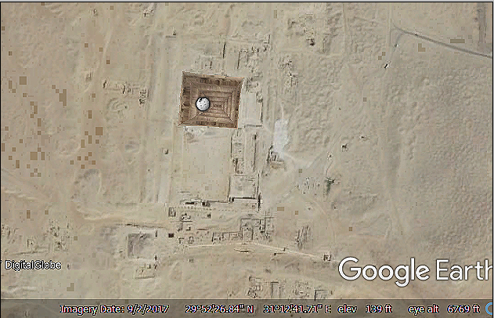

**Cultural Affiliation:** 25th-30th Dynasty-1069-500 BCE

**Medium:** bronze

**Dimensions:** 60.58 mm; 2.38 in

**Weight: 151 gm; 5.25 oz**

**Condition: original**

**Provenance:** unknown.

**Discussion:**

The worship of the bull in Egyptian history is very ancient. During the First Dynasty Apis worship is attested in the reign of Udymu (Palermo Stone, Schafer, p. 21, No. 12; Kahl 2007:29). During the second Dynasty Apis and Mnevis were worshipped at Hehopolis, and according to Manetho of Sebennytus, Apis was worshipped durng the 39-year reign of the Second Dynasty king Kaiechos [= Nebra ?] at Memphis and Mer-wer ("great black" = Mnevis) known as the living bull was worshipped at Hehopolis.

References

Gardiner, Alan H. 1997 *The royal canon of Turin*. Oxford: Griffith Institute of Oxford.

Kahl, J. 2007. *"Ra is My Lord": Searching for the Rise of the Sun God at the Dawn of Egyptian History.* Wiesbaden: Otto Harrassowitz Verlag,

*Manetho.* (The Loeb classical Library, Volume 350). Harvard University Press, Cambridge (Mass.) 2004, pp. 37–41.

[Pettigrew, T.J.](https://en.wikipedia.org/wiki/Thomas_Joseph_Pettigrew) (1834) - [*A History of Egyptian Mummies, and an Account of the Worship and Embalming of the Sacred Animals by the Egyptians with remarks on the funeral ceremonies of different nations, and observations on the mummies of the Canary Islands, of the Ancient Peruvians, Burman priests, & c.*](https://books.google.co.uk/books?id=ocpcAAAAcAAJ&pg) London: Longman, Rees, Orme, Brown, Green and Longman

Schafer, H. 1902. *Ein Bruchstilck altdgyptischen Annalen.* Berlin.